Redundancy Enhance VWM Recall Precision Independent of Encoding Durations
Redundancy Enhance VWM Recall Precision Independent of Encoding Durations
Visual information are not all unique, same visual features such as colour often repeat. Such redundancy is widely utilised in everyday environments: traffic lights, warning signs, and digital interfaces often repeat decision-relevant information to facilitate ease of detection and efficient use. In perceptual attention studies, this redundancy advantage is classically expressed as the redundant signal effect: responses are faster when multiple signals indicate the same response than when only one signal is present. Recent visual working memory (VWM) evidence demonstrated redundancy producing a distinct memory recall benefit—much more precisely than non-redundant items, without a corresponding response-time (RT) advantage. To further understand this redundancy precision gain, this study investigates whether redundancy improve memory precision because repeated information is encoded faster, or because it changes how information is represented, integrated, or read out from memory? We experimentally manipulated exposure duration in continuous colour-report tasks to address this question and gathered support for a post-encoding account of redundancy precision gain. However, to foreshadow, data insight from Experiment 1 contradicted current understanding of how we encode VWM representations. Three online follow-up experiments (and 2 more small-N in lab replications***) then tested whether this contradictory pattern challenges the established belief that encoding duration determines VWM representation quality.

Two Types of Redundancy Advantage
Visual redundancy, a basic form of visual information structure, has been used to diagnose two types of visual decision-making advantages—RT and accuracy (Gondan et al., 2020; Todd, 1912). Perceptually, two or more redundant signals often make their matched response faster than a singleton does. This advantage has been explained either through statistical facilitation (Miller 2016; Raab), in which multiple independent channels race toward response initiation; or through coactivation, in which redundant signals jointly contribute evidence to the same decision (Miller, 1982, 1986; Töllner et al., 2011). Importantly, the clearest RT benefits are usually observed in relatively simple perceptual decision tasks, such as signal detection, go/no-go responses, or speeded binary classifications, where the stimulus-response mapping is direct and accuracy is kept towards ceiling (Gondan et al., 2020; Grice & Canham, 1990). In more complex tasks, especially those using brief displays or requiring identification among multiple possible targets, redundancy can improve accuracy while the RT benefit is reduced or absent (Estes, 1966; Wolford, 1968; Eriksen, 1969; Kinchla, 1974; Grice, 1984; Shaw, 1982; Grice & Canham, 1990; Töllner et al., 2011). Thus, the behavioural expression of redundancy gain depends on task demands: redundancy may speed simple perceptual decisions, but when stimuli must be encoded, retained, or read out for report, its benefit may appear primarily as improved accuracy.
This distinction is important because older accuracy-based redundancy findings already suggest that redundancy effects are not limited to early perceptual response facilitation. Before visual working memory was clearly distinguished from iconic memory and other short-term visual stores (Phillips, 1974), redundancy accuracy benefits in brief-display tasks were used to adjudicate through perceptual neural summation accounts vs second-order summation accounts (Kinchla, 1974; Shaw, 1982). Specifically, neural summation consider redundancy as a low-level pooling of sensory evidence, whereas second-order summation accounts proposed that separate item-level decisions could be integrated to support the final response. In modern terms, this second-order view is closer to a memory-based or post-encoding decision process: information must first be encoded into reportable short-term representations (Duncan 1980; Oberauer & Hein, 2012), after which structured or repeated evidence can be integrated to support response. Consistent with this interpretation, information structure and organisation are known to influence what is retained and how accurately it can be reported from VWM (Jiang et al., 2000; Woodman et al., 2003; Alvarez, 2011; Brady et al., 2011; Brady & Tenenbaum, 2013). These earlier findings therefore motivate the central question of the present study: when redundancy improves VWM performance, does the advantage originate from enhanced perceptual encoding, or from post-encoding processes that are supported by structured memory representations?
Redundancy Measured Precisely
VWM supports decisions based on information that is no longer perceptually available, but the amount and quality of information it can maintain are severely limited. Classical change-detection studies suggested that observers can retain only a small number of visual objects, motivating item-capacity or slot-based accounts of VWM limits (Luck & Vogel, 1997, 2013; Cowan, 2001; Alvarez & Cavanagh, 2004; Zhang & Luck, 2008; Adam et al., 2017). Yet, the standard, hard slot limit accounts fail when stored information contain structure, because VWM encode features, summary information, structure, and perceptual chunks (e.g., redundancy; Brady & Tenenbaum, 2013; Chunharas & Brady, 2023). To explain the mechanism underlying redundancy, measuring how precisely we can represent feature values is thus more ideal.
Continuous report paradigms has been the choice task for VWM studies in recent two decades (Wilken & Ma, 2004), providing distribution of response errors around the reported feature value as an indication of memory quality (Wilken & Ma, 2004; Bays & Husain, 2008; Bays et al., 2009; van den Berg et al., 2012, 2014; Ma et al., 2014; Pratte, 2020). Precision measure supported resource and variable-precision accounts in which representational quality declines as memory load (i.e., number of unique items or features to remember) increases, due to limited VWM resources division. The neural population coding account (Bays et al., 2014; Van den Berg et al., 2012, 2014; Schurgin et al., 2020; Oberauer & Lin, 2017; Oberauer, 2023) and sample size account (Sewell et al., 2014; Smith et al., 2016; Smith 2018) are the current leading formalisations of continuous VWM resource division in neurally plausible terms, treating remembered features as noisy neural activity patterns over feature-tuned neuron populations. These models have been able to capture the gradual decline of precision as memory load increase. Importantly, redundancy can reduce effective load, bias resource allocation, strengthen a shared representation, or alter memory readout without necessarily changing whether an item is simply in memory.
Continuous Redundancy Precision Gain
Recently, Liu and Garrett et al. (in press) conducted a continuous colour report task to explore redundancy's effect. They used stimuli arrays with both redundant and non-redundant items and demonstrated a continuous redundancy precision gain at a cost to the non-redundant items in the same array, and without clear RT benefit. Thus, redundancy in VWM does not appear to operate simply as a classical redundant-signal effect carried over into delayed recall. Instead, it changes the quality of remembered information.
Combining the sample size framework with the class leading neural population model (i.e., signal discrimination model; Oberauer, 2023), Liu and Garrett et al. (in press) proposed a theoretical description of observed redundancy precision gain. First, precision decline was better predicted by a inverse power-law function of the number of unique colours in an array than by physical set size per se. This indicates a memory-rooted Gestalt representation for redundant items: repeated copies appear to be coded as a single unit in VWM, reducing effective memory load. Second, the severity of precision decline indicated that redundancy representation received more VWM resources than each of the other unique colours in the same array. Third, preferential allocation alone could not explain the full magnitude of the redundancy precision benefit; precision also scaled higher with the number of redundant elements in a manner consistent with summation or coactivation-style strengthening.
The second and third findings furthers our understanding of VWM redundancy gain, but they leave open whether biased resource allocation and joint strengthening are rooted in perceptual encoding or in memory processes. The gain could begin during perceptual encoding, or alternatively, arise from post-encoding processes. The present study tests such locus alternatives by asking whether the magnitude of VWM redundancy gain depends on exposure duration.
These prior findings also constrained the design of the present study. Liu and Garrett et al. (in press) observed the largest redundancy precision gain in arrays containing six items, with three redundant items sharing one colour and three non-redundant items each possessing a unique colour. We therefore used this display structure in Experiment 1 to maximise the redundant–non-redundant precision gap. At the same time, we kept set size and redundancy structure fixed across trials. This decision was motivated by Donkin et al. (2016), who showed that VWM resource allocation depends on whether the stimuli array context is predictable: when set size is randomised across trials, participants often encode only a subset of the array information; when set size is predictable, they tend to distribute resource across all stimuli in an array. Given the present question concerns the locus of redundancy gain, a fixed six-item, four-colour context was used to encourage full array encoding.

Encoding Rate Versus Post Encoding Accounts
Distinguishing whether VWM redundancy gain is rooted in perceptual encoding or in memory centric processes is important because brief display memory tasks involve multiple processing stages. Visual information must first be sampled and encoded, but later performance also depends on consolidation, storage, maintenance, and memory-based readout. A prominent view is that VWM representation quality depends on how much perceptual information is sampled before the display disappears (Palmer, 1990; Bays et al., 2011; Ramzaoui et al., 2025). Bays et al. (2011) directly supported this view in a masked continuous-report task, showing that recall precision improved over several hundred milliseconds before approaching a capacity-limited asymptote. Their model further suggested that encoding rate declined with increasing set size, positing that stimuli compete for limited encoding capacity.
Broader perceptual attention research also aligns with the encoding rate account of redundancy. Attention can improve perceptual performance by enhancing signal processing, excluding external noise, or increasing the effective quality of sensory evidence (Dosher & Lu, 1998, 1999; Lu & Dosher, 2008; Carrasco, 2011, 2014). Redundancy as a perceptual group may be more salient to attract attention earlier (Woodman et al., 2003; Ramzaoui et al., 2025), and may jointly strengthen sensory evidence through summation or coactivation-like processes (Shaw, 1982; Töllner et al., 2011). In this view, VWM redundancy gain originates during encoding: redundant feature encoded as a common high quality memory representation sooner than non-redundant features. The redundancy advantage should therefore be largest when exposure duration is brief and should shrink as longer exposure allows non-redundant items to catch up
In contrary, consistently observed VWM behavioural patterns cannot be attributed entirely to simultaneous perceptual competition during encoding. Sequential presentation studies have shown equivalent set size deficits even when items are presented one by one, suggesting that the true bottleneck is post initial perceptual selection—during consolidation, storage, or memory-based decision processes (Sewell et al., 2014; Lilburn & Smith, 2020). A post encoding account of redundancy precision gain therefore predicts a different temporal pattern. If the mechanism that repeated features jointly strengthen a recall response reflects primarily post-encoding processes, redundancy gain magnitude should remain comparatively stable across exposure durations.
The Suprise of a Flat Encoding Duration Function
A temporally stable redundancy gain would support the post-encoding account, but it would also raise a second issue if overall recall precision did not improve with longer encoding window. If both redundant and non-redundant responses show little improvements across the asymptote window shown by Bays et al. (2011), the result would not only support post encoding redundancy advantage, but also challenge the broadly held view that longer exposure duration necessarily improves VWM representation quality. To foreshadow, Experiment 1 data necessitated asking a separate question: does increasing exposure duration ubiquitously improves recall precision.
Experiment 1 used a fixed, predictable display context as described above, however, the same design choice could also facilitate practice effect. Experiment 1 used a small-n design (Smith & Little, 2017), where participants completed thousands of trials with the same array structure, giving them extensive opportunity to learn to use encoding attention, consolidation strategy, or VWM resource more efficiently. In this sense, the fixed-context design may have made Experiment 1 a clean test of the redundant–non-redundant precision gap, but left open why encoding duration may not always determine VWM quality.
If predictable memory demands encourage more effective memory resource allocation, then highly practiced observers in a fixed six-item, four-colour context may be able to allocate resources efficiently even with a very short exposure duration (e.g., 50 ms). A flat exposure-duration function would therefore not necessarily imply that encoding duration is irrelevant for VWM precision in general. Instead, it may indicate that, under a predictable and extensively practiced array context, participants rapidly reached the task-specific precision limit imposed by VWM resource allocation, stimulus simplicity, or both.
Three complementary experiments were designed to evaluate this possibility. If the flat exposure-duration function in Experiment 1 reflects extensive practice, then naïve online participants, the addition of more variable array contexts (i.e., all unique colour conditions in multiple set sizes), and the further addition of more demanding multi-feature stimuli (i.e., coloured orientation bars used in Bays et al., 2011) were expected to show a more conventional improvement with exposure duration.

Methods
We report one laboratory experiment and three complementary online experiments to test whether VWM recall redundancy gain and non-redundant cost depend on stimuli exposure duration. Experiment 2 comprised three online experiments designed to evaluate alternative explanations for the observed pattern in Experiment 1. All experiments used the same delayed continuous-reproduction procedure in which participants reproduced a probed visual feature after a brief memory display and retention interval.
Data and code available at***
Ethics approval***
Experiment 1
Participants
Experiment 1 recruited five participants from the University of Melbourne—four members of the Vision and Attention Laboratory and one volunteer participant (i.e., small-N high trial count design; Smith & Little, 2017). All participants (one female and four males; mean age = x***; age range = *** to 43 years) reported normal or corrected-to-normal vision and no history of colour-vision deficiency. Participants were required to complete ten sessions each, with each session consisting of 420 experimental trials. One participant was excluded prior to completion after failing to perform the task reliably across five sessions. The final sample therefore consisted of four participants.
Apparatus
Experiment 1 was programmed in MATLAB (2024b) using Psychtoolbox and presented on a *** monitor operating at approximately 60*** Hz refresh rate. Participants used a chin rest and viewed the display at approximately 60 cm distance in a dimly lit laboratory test room.
Stimulus size was calibrated in visual angle using a monitor calibration procedure at the beginning of the experiment. The stimulus array occupied approximately 5° of visual angle centered on fixation.
Stimuli
Stimuli consisted of coloured circular patches presented on a uniform grey background (RGB = 128, 128, 128***). Stimuli each subtended approximately 1° of visual angle and were positioned on an invisible circular ring centered on fixation. Equally spaced stimulus locations were used on each trial, with the angular orientation of the array randomly rotated between trials.
Stimulus colours were sampled from a circular colour space generated in OKLab space. The colour wheel was constructed at a fixed luminance plane (L = 0.85) with chromatic radius fixed at 0.23. Colours were converted to RGB values for display presentation. Compared with traditional CIE-based colour spaces, OKLab was chosen because it provides improved perceptual uniformity across hue transitions (citation***). A minimum separation of 30° within colour space was enforced between distinct colours appearing within a given array.
Design
Experiment 1 was a within-subject design. Trials always contain six items, three of which shared the same colour value (redundant items), while the rest each possessed unique colour values (non-redundant items), resulting in four unique colour values per array. The spatial positions of redundant items were randomized on each trial and were not constrained to form grouped or separated spatial configurations. Consequently, redundant items could appear adjacent to one another or spatially dispersed in the array.
The key manipulation was encoding duration, with seven levels: 50, 100, 150, 200, 250, 300, and 350 ms. A second manipulation was cue type. On each trial, the cued item was either a redundant item (R-cue) or a non-redundant item (NR-cue). Exposure duration and probe type were fully crossed, producing 14 experimental conditions. Each condition was repeated 30 times per session, resulting in 420 experimental trials per session of 10 total sessions.
Procedure
Each of the 10 sessions began with 14 practice trials (one of every condition) prior to experimental trials. Each experimental trial began with a central fixation display presented for 1000 ms. A memory array consisting of six coloured stimuli was then presented for one of the seven exposure durations. Immediately following the stimulus offset, a visual mask was presented for 750 ms. After the retention interval, a response display showed gray patches replacing the original stimuli, with one patch being cued with a white outline, and a circular colour wheel concentric to the array. The inner and outer wheel boundaries extended approximately 9.5° and 10.5° visual angles respectively.
The colour wheel orientation was randomly rotated once per session to reduce the use of stable spatial-response mappings. At response onset, the mouse cursor was reset to the central fixation. Participants reproduced the target’s colour by moving the cursor from the fixation toward the colour wheel. A response was registered when the cursor crossed the inner boundary of the response wheel. RT was measured from onset of the response display until response registration.
Experiment 2
Participants
Experiment 2 comprised three online sub-experiments. Participants were recruited through Prolific and the University of Melbourne SONA system to complete the experiments remotely in a web browser. A total of 227 participants (Prolific N = 97; SONA N = 130) were recruited; one prolific participant returned no usable data following a system crash, leaving 226 participants in the analyzed sample. Table 1 shows sample and demographic information per sub-experiment.
Table 1
Sample size and participant demographic information broken down by sub-experiments
 |  | Sample | Gender | Mean_{Age} | SD_{Age} | Range_{Age}
Prolific | Exp 2-1 | N = 32 | M = 13; F = 18; N = 1 | 36.9 | 12.5 | 21-73
 | Exp 2-2 | N = 32 | M = 13; F = 18; N = 1 | 37.8 | 13.0 | 22-69
 | Exp 2-3 | N = 32 | M = 13; F = 18; N = 1 | 37.8 | 11.8 | 19-66
REP | Exp 2-1 | N = 43 | M = 13; F = 18; N = 1 | 19.5 | 1.9 | 18-26
 | Exp 2-2 | N = 45 | M = 13; F = 18; N = 1 | 19.1 | 2.2 | 18-32
 | Exp 2-3 | N = 42 | M = 13; F = 18; N = 1 | 19.0 | 1.1 | 17-22
ALL | Exp 2-1 | N = 75 | M = 13; F = 18; N = 1 | 26.9 | 11.9 | 18-73
 | Exp 2-2 | N = 77 | M = 13; F = 18; N = 1 | 26.9 | 12.6 | 18-69
 | Exp 2-3 | N = 74 | M = 13; F = 18; N = 1 | 27.2 | 12.2 | 17-66

All participants reported normal or corrected-to-normal vision and no colour-vision deficiency. Prolific participants were compensated at an average rate of £8.94/hr. Recruitment used a filtered Prolific participant list [CHDH list details**] intended to include credible and attentive participants.
Apparatus
Experiment 2 was implemented in jsPsych webstack and run in participants’ web browsers. Access was restricted to personal computers; mobile phones and tablets were not permitted.
Before beginning the task, participants were instructed to sit approximately an arm’s length from their screen. Participants then completed a display-size calibration procedure in which they adjusted a pair of horizontally positioned bars to match the length of a standard credit card. This procedure scaled the displayed stimuli to approximate the laboratory viewing geometry used in Experiment 1 under remote testing conditions. After the calibration procedure, the experiment automatically entered fullscreen mode.
jsPsych version, and fullscreen re-entry and exit detail***
Shared Online Procedure
All three online sub-experiments followed the same general delayed continuous-report structure as Experiment 1. Trials began with fixation, followed by a briefly presented memory array, a 750 ms masked retention interval, and a response display where participants reported the cued feature using a continuous response wheel. RT was measured from response display onset until response registration.
Experiment 2 used the same exposure-duration logic as Experiment 1 where applicable, but each sub-experiment differed in the number of durations, set sizes, and stimulus features.
Experiment2-1: Replicate Experiment 1 to Assess Practice Effect
Experiment 2-1 tested whether the weak exposure-duration effect observed in Experiment 1 reflected extensive task practice in the small-N laboratory design. It was therefore designed as a direct online replication of Experiment 1 using naïve online participants.
Experiment 2-2: Array Context-Variability Manipulation
Experiment 2-2 tested whether the fixed display structure in Experiment 1 allowed participants to learn an efficient resource allocation strategy across trials. To reduce contextual predictability, set size varied between four and six items, and trials varied in redundancy structure.
For set size 4, redundancy trials contained two redundant items. For set size 6, redundancy trials contained three redundant items. For both set sizes, there were three trial types: baseline trials containing only unique colours, redundancy trials in which the cued item was redundant (R-cue), and redundancy trials in which the cued item was non-redundant (NR-cue).
Exposure duration varied across three levels: 50, 150, and 250 ms. The full design therefore crossed exposure duration, set size, and trial type, producing 18 experimental conditions. Each condition was repeated 20 times, yielding 360 experimental trials per participant.
Experiment 2-3: Multi-feature Stimulus Manipulation
Experiment 2-3 tested whether encoding-duration effects depend on multi-feature binding demands. The factorial structure of Experiment 2C matched Experiment 2B. However, stimuli were coloured orientation bars instead of single feature colour patches. Participants were cued by colour and reproduced the remembered orientation of the target stimulus using a continuous orientation wheel.
Experiment 2-3 preserved the set-size, redundancy, and exposure-duration manipulations of Experiment 2-2 while introducing an additional feature-binding requirement similar to that used by Bays et al. (2011).
Preliminary participant-level analyses
Preliminary linear mixed-effects models were fitted separately for participant (AQ, HC, and YILIU, YDL TBC) using absolute angular error as the outcome. Cue type (R-cue vs. NR-cue), encoding duration (50–350 ms; categorical), standardized session progression, and their interactions were entered as fixed effects. Session was included as a random intercept to account for clustering of trials within sessions. Models were fitted using restricted maximum likelihood with the nlme package in R.
From each participant model, planned contrasts estimated the 50-to-350-ms change in absolute error separately for R- and NR-cue trials during early sessions, at the average session, and during late sessions. Negative values indicated lower error at 350 ms. NR catch-up was defined as (R350 − R50) − (NR350 − NR50), so that positive values indicated greater improvement for NR than R. Catch-up progression was tested as late catch-up minus early catch-up. Model-estimated cue × duration means were also reported with standard errors and 95% confidence intervals at each session slice.
To characterize each cue condition independently, additional models were fitted separately to R- and NR-cue trials, with encoding duration, standardised session, and their interaction as fixed effects. Model-estimated 50-to-350-ms changes were compared between early sessions (Sessions 1–2) and late sessions (Sessions 9–10) to test whether duration-related improvement diminished with practice.
Primary Bayesian analysis
Primary inference used participant-level Bayesian regression models fit separately for each complete participant (AQ, HC, YILIU), consistent with the small-N intensive replication design. Each model predicted trial-wise absolute error (AbsErr, degrees) as: AbsErr ~ CueType × DurationF × Session_z + (1 | SessionF).
Cue type (NR vs R) and encoding duration (50–350 ms in 50-ms steps) were categorical predictors. Session progression was modelled continuously (Session_z). A random intercept for session accounted for trial clustering within sessions. Outliers were accommodated with a Student-t likelihood.
Weakly informative priors were placed on the intercept (Normal[30, 20]), fixed effects (Normal[0, 15]), residual scale (Exponential[1]), random-effect SD (Exponential[1]), and degrees of freedom (Gamma[2, 0.1]). Models were fit in brms with four chains, 4,000 iterations (2,000 warmup), adapt_delta = 0.95, and max_treedepth = 12. All chains converged satisfactorily (R̂ ≈ 1.00).

Posterior contrasts
Theoretical contrasts were computed on posterior draws of model-estimated marginal means (emmeans). Uncertainty was summarised with posterior medians, 95% credible intervals (CrIs), directional probabilities (P(effect < 0) or P(effect > 0)), and practical-equivalence probabilities using a region of practical equivalence (ROPE) of ±3°.
Four contrast families were evaluated:
- Redundancy advantage: NR − R AbsErr at 50 ms (and across durations).
- Encoding-duration change: For each cue separately, (i) a linear trend across ordered durations and (ii) a 350 ms − 50 ms contrast at average session (Session_z = 0). Negative values indicate lower error with longer encoding.
- Catch-up: (R duration change) − (NR duration change) for the 350 ms − 50 ms contrast, evaluated at early (Sessions 1–2), average, and late (Sessions 9–10) sessions, plus late − early catch-up change. Positive values indicate NR improved more than R.
- Practice: Late − early change in each cue’s 350 ms − 50 ms effect.
Participant-level frequentist mixed models’ outcome are consistent, and are placed in the appendix.

- Ethics approval number and exact approved protocol wording.
- Monitor model, resolution, physical size, and actual refresh rate for Experiment 1.
- Whether Experiment 2 includes only Prolific participants or Prolific \+ REP participants.
- jsPsych version and server/webstack details.
- Exact handling of fullscreen violations, browser/device checks, and failed calibration.
- Exact online exclusion criteria.
- Citation for OKLab perceptual uniformity.

Results
Experiment 1
Figure 1-1 shows the precision variability (i.e., circular standard deviation) by encoding durations for each of the 4 retained participants. Figure 1-2 shows RT median by encoding durations for each participant.
Precision descriptive plots show mostly flat encoding duration function for most participants. RT descriptive plots show a slight but seemingly stable R-cued advantage in three of four participants.
Figure 1-1: Experiment 1 Participant Level Precision
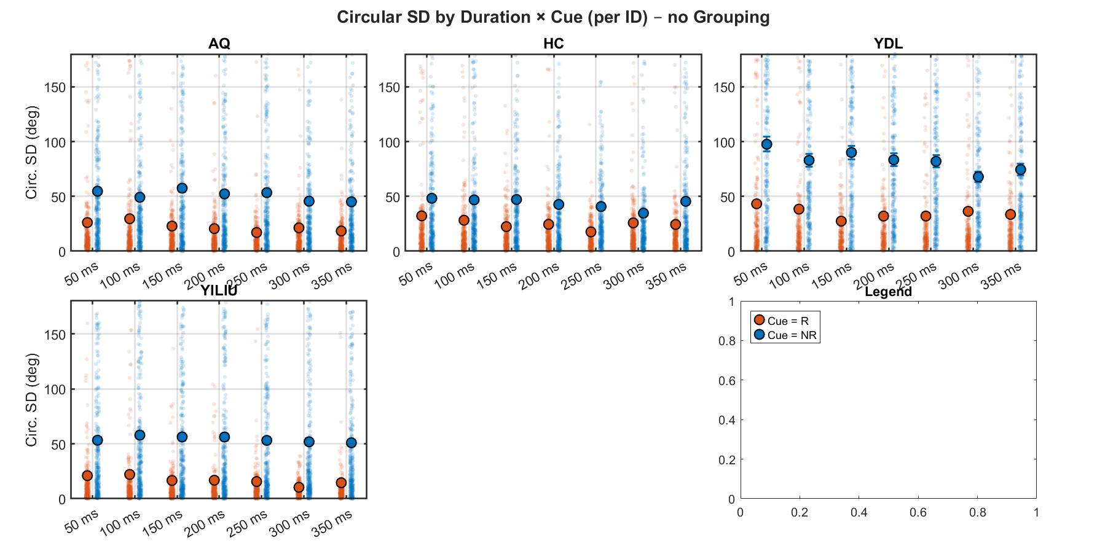
Note. Red dots are R-cued; blue dots are NR-cued; small, faded points show precision per trial.
Figure 1-2: Experiment 1 Participant Level RT
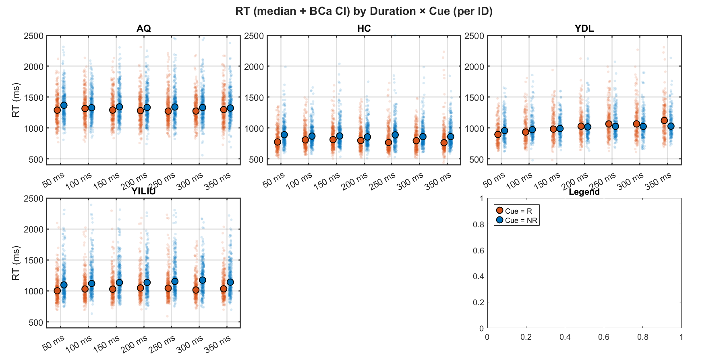
Experiment 2
Figures 2-1, 2-2, and 2-3 correspond to Experiment 2-1, 2-2, and 2-3, showing precision variability by encoding durations.
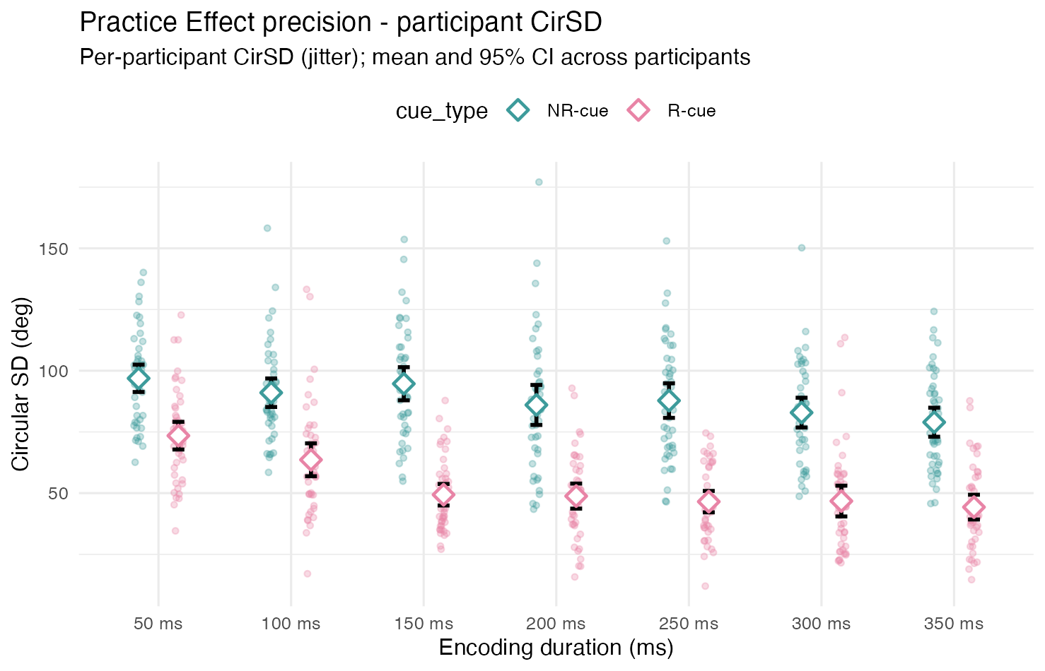
Figure 2-1
Note. Faded points show participant level circular SD; diamonds show group level circular SD with 95% CI error bars. Red indicates R-cue, blue indicates NR-cue.

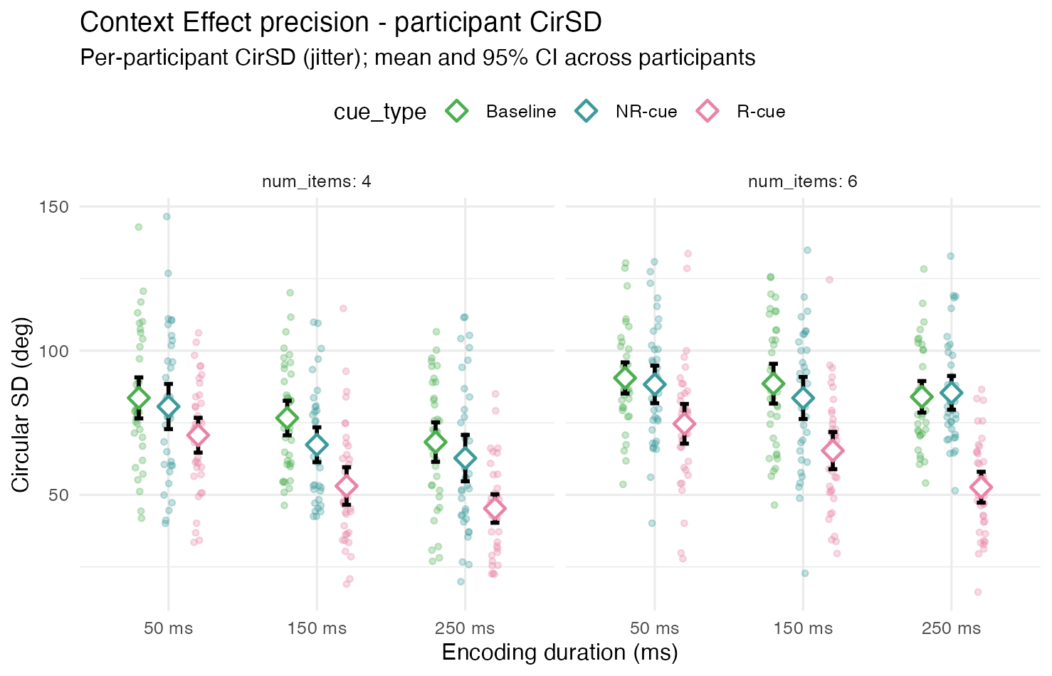
Figure 2-2
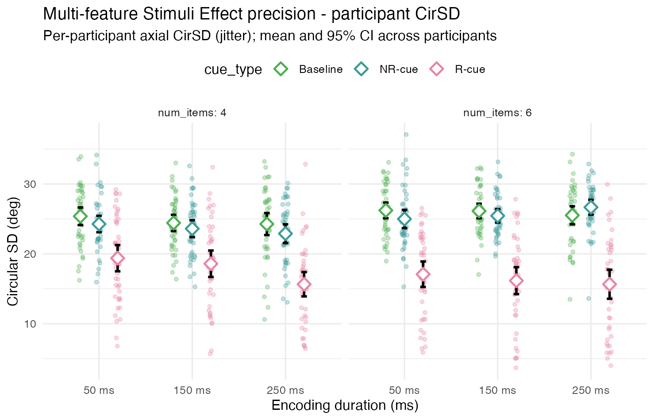
Figure 2-3

Preliminary participant-level analyses
Descriptively, R-cue absolute error and circular SD were lower than NR-cue values across durations and session phases for all three participants. Absolute-error redundancy gain (NR − R) ranged approximately 9–38° for AQ, 7–22° for HC, and 23–35° for YILIU across session phases; circular SD gain showed the same directional pattern.
In the joint models, the R-cue advantage at the 50-ms reference duration and average session was significant for AQ, F(1, 4164) = 83.02, p < .001; HC, F(1, 4164) = 32.14, p < .001; and YILIU, F(1, 4163) = 88.19, p < .001. Cue type interacted with duration for AQ, F(6, 4164) = 2.43, p = .024, and HC, F(6, 4164) = 2.39, p = .026, but not YILIU, F(6, 4163) = 0.43, p = .856. The full cue × duration × session interaction was nonsignificant for all three participants (AQ: p = .286; HC: p = .539; YILIU: p = .860).
Catch-up contrasts provided little consistent support for greater NR than R improvement from 50 to 350 ms. For AQ, catch-up was nonsignificant early, b = −6.01°, 95% CI [−18.63, 6.61], p = .350, and at the average session, b = 3.84°, 95% CI [−3.52, 11.20], p = .306, but was significant late, b = 13.70°, 95% CI [1.08, 26.31], p = .033. The early-to-late increase in catch-up was marginal, b = 19.71°, 95% CI [−0.79, 40.21], p = .059.
For HC, catch-up was nonsignificant early, b = 2.18°, 95% CI [−9.32, 13.69], p = .710; at the average session, b = −1.89°, 95% CI [−8.60, 4.82], p = .581; and late, b = −5.96°, 95% CI [−17.47, 5.54], p = .310. Catch-up progression was also nonsignificant, b = −8.15°, 95% CI [−26.83, 10.54], p = .393.
For YILIU, catch-up was nonsignificant early, b = 2.39°, 95% CI [−10.82, 15.61], p = .723; at the average session, b = −1.51°, 95% CI [−9.22, 6.19], p = .700; and late, b = −5.42°, 95% CI [−18.63, 7.80], p = .421. Catch-up progression was nonsignificant, b = −7.81°, 95% CI [−29.28, 13.66], p = .476.
Cue-specific models indicated duration-related variation for both cue types in AQ and HC, and for R-cue trials only in YILIU. No cue-specific duration × session interaction was significant, and none of the early-to-late changes in the 50–350-ms contrast reached significance (all ps ≥ .074).
Overall, these sensitivity analyses replicated a robust R-cue absolute-error advantage, but they did not provide consistent evidence that NR items catch up with longer encoding durations or that practice systematically reshapes catch-up within the tested duration range.
Primary Bayesian Hierarchical Regression Results
Redundancy advantage
R-cued reports were more precise than NR-cued reports in all three participants. At 50 ms and average session, redundancy gain (NR − R) was 10.3° [7.9, 12.9] for AQ, 4.6° [2.2, 7.1] for HC, and 6.2° [4.0, 8.3] for YILIU (all P(gain > 0) > .999). This effect replicated clearly, though it was not the primary theoretical target.
Encoding-duration effects
Against the encoding-rate prediction that AbsErr should decrease monotonically with longer exposure, duration effects were weak and cue-dependent.

For R-cued trials, the 350 ms − 50 ms change was small in all participants (medians −1.4°, −0.9°, and −0.5° for AQ, HC, and YILIU) and largely within the ±3° ROPE (96–100% of posterior mass). There was little Bayesian support for systematic R-cue improvement across the 50–350 ms range.
For NR-cued trials, duration effects were stronger but not fully replicated. AQ showed a clear reduction in error from 50 to 350 ms (−4.5° [−7.4, −1.7]; P(improvement) = .999). HC showed a smaller effect in the same direction (−2.7° [−5.3, −0.08]; P = .978). YILIU showed no reliable change (−0.2° [−2.6, 2.3]; 98% of posterior mass in ROPE). Linear-trend contrasts pointed in the same direction for AQ and HC for NR, but were less decisive for YILIU. I also must note that these NR error reduction effects are small in comparison to prior evidence in the literature.
Overall, the data did not support a general monotonic duration benefit; when present, it was confined mainly to NR-cued trials in two of three participants.
Catch-up (NR vs R duration change)
The perceptual-encoding account predicts that NR should improve more than R with longer encoding (positive catch-up). This was not consistently supported. At average session, catch-up was directionally positive for AQ (3.2° [−0.05, 6.4]; P > 0 = .973) but the 95% CrI included zero and 46% of posterior mass fell within ROPE. HC showed a smaller, uncertain positive trend (1.8° [−1.5, 5.2]; 75% in ROPE). YILIU showed no catch-up (−0.3° [−3.0, 2.4]; 97% in ROPE). Early- and late-session catch-up estimates were similarly wide and participant-specific; late − early catch-up change did not show a replicated pattern (AQ +2.5°, HC −2.8°, YILIU +0.2°; all CrIs spanned zero). Thus, the models did not provide strong evidence that NR “catches up” to R with longer encoding.
Practice effects
Practice did not reliably reshape duration or catch-up patterns. Late − early changes in the 350 ms − 50 ms effect were uncertain for both cues in all participants (e.g., NR: AQ −5.0° [−13.0, 2.9], HC +5.8° [−1.6, 13.2], YILIU +1.0° [−6.5, 7.9]; R effects similarly straddled zero/ROPE). This supports treating within-session duration structure as largely stable over training in Experiment 1, and motivates the planned large-N online follow-ups for practice-related questions.
Summary across participants
Bayesian primary models replicated three conclusions: (1) a robust redundancy advantage for R over NR; (2) little evidence for duration-related improvement in R-cued reports; and (3) no consistent NR catch-up. NR duration effects were participant-dependent rather than replicated. These findings favour a mnemonic or post-encoding contribution to redundancy gain over a simple encoding-rate account within the tested 50–350 ms window.

References

